

INTERNSHIP REPORT
Title
Verification of a 4-Request Round Robin Arbiter using a Self-Checking System Verilog Test-bench
Conducted By
BNM Institute of Technology, Bengaluru in Association with Cranes Varsity
Branch: Electronics & Communication Engineering
Duration: 13 July 2026 - 31 July 2026
Faculty Coordinators:
Dr. Subodh Kumar Panda, Professor, ECE Department
Dr. Smitha Gayathri D, Associate Professor, ECE Department
Ms. Kanchana Reddy, Trainer & SME, Cranes Varsity Pvt. Ltd.
Team Members
Sl. No. | Name | USN
1 | Neeharika P Kumar | 1BG24EC121
2 | Nishitha K R | 1BG24EC119

Academic Year: 2026-27

Certificate
(To be signed by the Faculty Coordinator after successful completion.)
This is to certify that Neeharika P Kumar (USN: 1BG24EC121) and Nishitha K R (USN: 1BG24EC119) have successfully completed the internship titled “Verification of a 4-Request Round Robin Arbiter Using a Self-Checking System Verilog Testbench”, conducted by BNM Institute of Technology in association with Cranes Varsity, from 13 July 2026 to 31 July 2026. During this period, the interns designed and verified a 4-Request Round Robin Arbiter using a class-based System Verilog testbench, applying directed and constrained-random verification techniques, automatic self-checking using a scoreboard, and functional simulation.

Faculty Coordinator Signature Department HOD Signature

Acknowledgement
We would like to express our sincere gratitude to the management of BNM Institute of Technology for providing us with the opportunity to undertake this internship, and to our Principal for the continued encouragement of industry-linked learning. We are thankful to the Head of the Department of Electronics & Communication Engineering for supporting this internship as part of our academic curriculum.
We are deeply grateful to our faculty coordinators, Dr. Subodh Kumar Panda and Dr. Smitha Gayathri D, for their guidance, timely feedback, and constant encouragement throughout the internship. We would also like to thank Ms. Kanchana Reddy and the rest of the resource team at Cranes Varsity for their structured training on RTL design and SystemVerilog-based verification, and for their patience in clarifying our doubts during the sessions.
Finally, we thank our peers and team members for the valuable discussions during the verification project, which helped us understand different perspectives on digital design and verification, and our families for their constant support throughout this internship

Table of Contents
Certificate 2
Acknowledgement 3
List of Figures 5
List of Tables 5
Abbreviations 5
1. Introduction 6
2. Problem Statement 7
3. Objectives 8
4. Background 8
5. System Architecture 10
6. Design Methodology 11
7. System Verilog Implementation 12
8. Verification Methodology 13
9. Simulation Results 15
10. Challenges & Solutions 18
11. Learning Outcomes 18
12. Conclusion & Future Scope 19
Annexure: Source Code Listings 20

List of Figures
Figure 1: Conceptual block diagram of a 4-Request Round Robin Arbiter showing request inputs, arbitration logic, priority pointer, and grant outputs..
Figure 2: Modular System Verilog Testbench Architecture for the Verification of a 4-Request Round Robin Arbiter
Figure 3: Simulation Waveform of the Round Robin Arbiter.

List of Tables
Table 1 summarizes the parameter values used for the design instance verified in this project.
Table 2: Signal activity summary derived from the simulation waveform.
Table 3: Simulation Results of the Round Robin Arbiter.
Table 4: Challenges encountered during the project and the solutions adopted.

Abbreviations

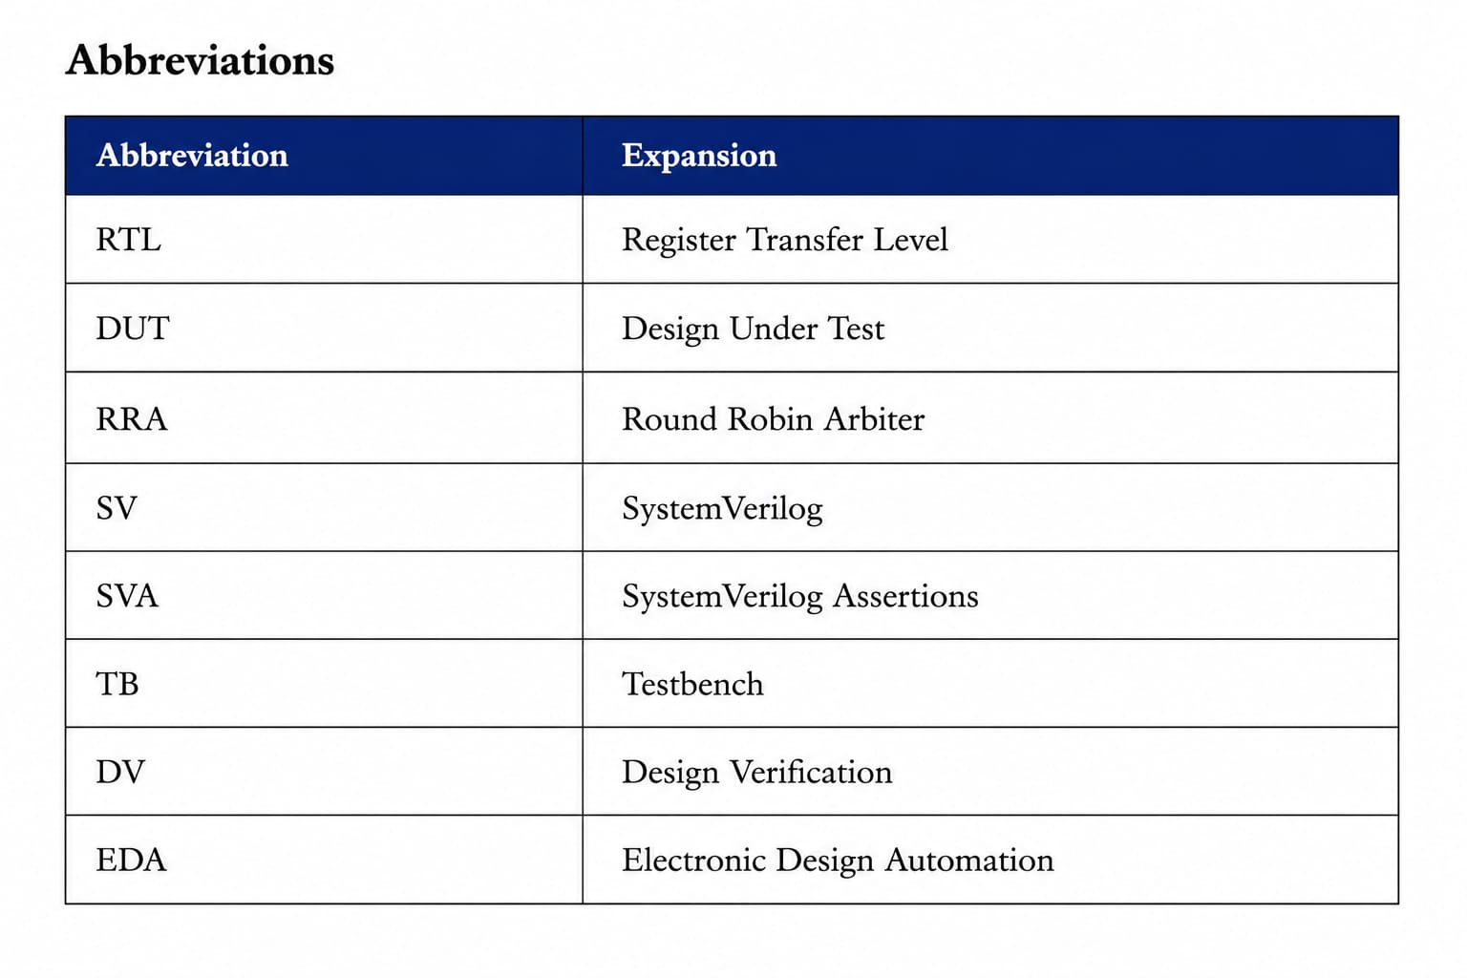

1. Introduction

1.1 About the Internship
This internship, titled “Design Verification Using SystemVerilog,” was conducted by BNM Institute of Technology in association with Cranes Varsity from 13 July 2026 to 31 July 2026. The internship was designed to introduce students to industry-standard digital design and functional verification practices, moving beyond classroom RTL design into the structured, tool-supported verification methodologies used in the VLSI industry.
The programme covered RTL design fundamentals in Verilog, simulation and waveform debugging, and a progressively deeper treatment of SystemVerilog as a verification language — including class-based testbench components, constrained-random stimulus generation, mailboxes for inter-process communication, concurrent assertions (SVA), and functional coverage. Simulations were carried out using the Synopsys VCS simulator, giving hands-on exposure to a professional EDA toolflow rather than only open-source or academic simulators.
The centerpiece of this internship was an individual project on the verification of a 4-request Round Robin Arbiter using SystemVerilog. A self-checking verification environment was developed with components such as a generator, driver, monitor, mailbox, and scoreboard to validate the arbiter's functionality using randomized test cases. The project focused on ensuring fair resource allocation by automatically comparing expected and actual outputs. This report presents the design methodology, verification architecture, simulation results, challenges encountered, and the key learning outcomes gained throughout the internship.

1.2 About the Project
The project focuses on the functional verification of a 4-request Round Robin Arbiter, a digital circuit used to provide fair access to shared resources among multiple requesters. While the RTL design ensures round robin arbitration, verifying its correctness under different request patterns is equally important. A modular, self-checking SystemVerilog verification environment was developed to validate the arbiter's functionality. The testbench consists of components such as a generator, driver, monitor, mailbox, and scoreboard to automate the verification process. Randomized test cases were generated to exercise various input combinations and arbitration scenarios. The scoreboard continuously compared the expected and actual outputs to detect mismatches automatically. Simulation and debugging were performed using the Synopsys VCS simulator. The project verified correct grant generation, fair priority rotation, and reliable operation under different request conditions. This report presents the verification methodology, simulation results, challenges encountered, and the key learning outcomes gained during the project

1.3 Report Organization
Section 2 presents the problem statement addressed by the project, while Section 3 outlines the project objectives. Section 4 provides background information on the Round Robin Arbiter and SystemVerilog-based functional verification. Sections 5 through 8 describe the system architecture, RTL design methodology, Verilog/SystemVerilog implementation, and verification methodology. Section 9 presents the simulation results obtained using the Synopsys VCS simulator. Section 10 discusses the challenges encountered during implementation and the solutions adopted. Section 11 summarizes the learning outcomes gained throughout the internship, and Section 12 concludes the report while highlighting possible future enhancements. Complete source code listings are included in the Annexure.
2. Problem Statement
In modern digital systems, multiple devices or processing units frequently compete for access to shared resources such as memory, communication buses, and peripheral devices. When several requests occur simultaneously, an arbitration mechanism is required to determine which requester is granted access. If an efficient arbitration scheme is not implemented, some requesters may repeatedly receive higher priority while others experience starvation, resulting in unfair resource allocation and reduced overall system performance.
A Round Robin Arbiter is a widely used arbitration technique that addresses this issue by allocating access in a cyclic manner. Instead of assigning fixed priorities, it rotates the priority among all requesters after each successful grant, ensuring that every requester receives a fair opportunity to access the shared resource. This approach prevents starvation, improves resource utilization, and provides balanced access among all requesting devices, making it suitable for high-performance digital systems.
Although designing the Register Transfer Level (RTL) implementation of a Round Robin Arbiter is relatively simple, verifying its functionality is equally important. The arbiter must operate correctly under different request conditions, including single requests, multiple simultaneous requests, continuous request patterns, and situations where no requests are active. Any error in the arbitration logic may result in incorrect grant generation, improper priority rotation, or unfair allocation of resources, affecting the overall reliability of the system.
Manual verification using a limited number of test vectors is not sufficient to validate all possible input combinations and operating scenarios. As digital designs become more complex, an automated and structured verification methodology is essential to improve verification efficiency, detect design errors early, and ensure functional correctness.
This project addresses these challenges by developing a self-checking SystemVerilog verification environment for a 4-request Round Robin Arbiter. The verification environment consists of modular components such as a transaction, generator, driver, monitor, mailbox, scoreboard, environment, and test, which work together to automate the verification process. Randomized test cases are generated to exercise different request combinations, while the scoreboard automatically compares the expected and actual grant outputs to identify mismatches without manual intervention. The verification process validates correct grant generation, proper priority rotation, fair arbitration, and reliable operation of the arbiter under various request scenarios, thereby increasing confidence in the correctness and robustness of the RTL design.
3. Objectives
The primary objective of this project is to design and functionally verify a 4-request Round Robin Arbiter using Verilog RTL and a self-checking SystemVerilog verification environment. The project aims to provide practical exposure to industry-standard digital design and verification methodologies by implementing a complete verification flow, from RTL design to simulation, debugging, and automatic result checking. It also focuses on understanding how a structured verification environment improves the reliability, efficiency, and reusability of the verification process while ensuring the correct functionality of the arbiter under various operating conditions.

The specific objectives of this project are as follows:
- To understand the working principle and importance of a Round Robin Arbiter in digital systems.
- To design and implement a 4-request Round Robin Arbiter using Verilog RTL coding.
- To develop a modular and reusable SystemVerilog verification environment based on object-oriented programming concepts.
- To implement verification components such as Transaction, Generator, Driver, Monitor, Mailbox, Scoreboard, Environment, and Test.
- To establish communication between different verification components using mailboxes and virtual interfaces.
- To generate randomized request patterns for verifying different arbitration scenarios.
- To verify correct grant generation for single-request and multiple-request conditions.
- To validate proper priority rotation among all requesters to ensure fairness and eliminate starvation.
- To implement a self-checking scoreboard that automatically compares the expected and actual outputs of the arbiter.
- To perform simulation, waveform analysis, debugging, and functional verification using the Synopsys VCS simulator.
- To understand the complete verification flow followed in the VLSI industry, including stimulus generation, DUT driving, monitoring, result checking, and simulation analysis.
The project also aims to strengthen the understanding of SystemVerilog verification concepts such as constrained-random stimulus generation, mailbox-based communication, class-based testbench development, and automated result checking. By developing a reusable and modular verification environment, the project demonstrates how modern verification methodologies reduce manual effort and improve verification efficiency. Overall, the project provides practical knowledge of RTL design, functional verification, debugging, and simulation while preparing students for advanced verification techniques such as assertions, functional coverage, and Universal Verification Methodology (UVM), which are widely used in the semiconductor industry.

4. Background
A Round Robin Arbiter is a digital circuit used to provide fair access to a shared resource when multiple devices or modules request it simultaneously. Unlike a fixed-priority arbiter, which always grants access to the highest-priority requester, a Round Robin Arbiter rotates the priority after every successful grant. This cyclic priority mechanism ensures that each requester gets an equal opportunity to access the shared resource, thereby preventing starvation and improving fairness in resource allocation.
Round Robin arbitration is widely used in modern digital systems such as AMBA bus arbitration, AXI interconnects, memory controllers, DMA controllers, network routers, and multi-core processors, where multiple masters compete for shared resources. Since the arbiter is responsible for deciding which requester gains access to the shared resource, any error in the arbitration logic may result in incorrect grant generation, unfair resource allocation, or improper priority rotation. Therefore, functional verification plays a vital role in ensuring the reliability and correctness of the arbiter before hardware implementation.
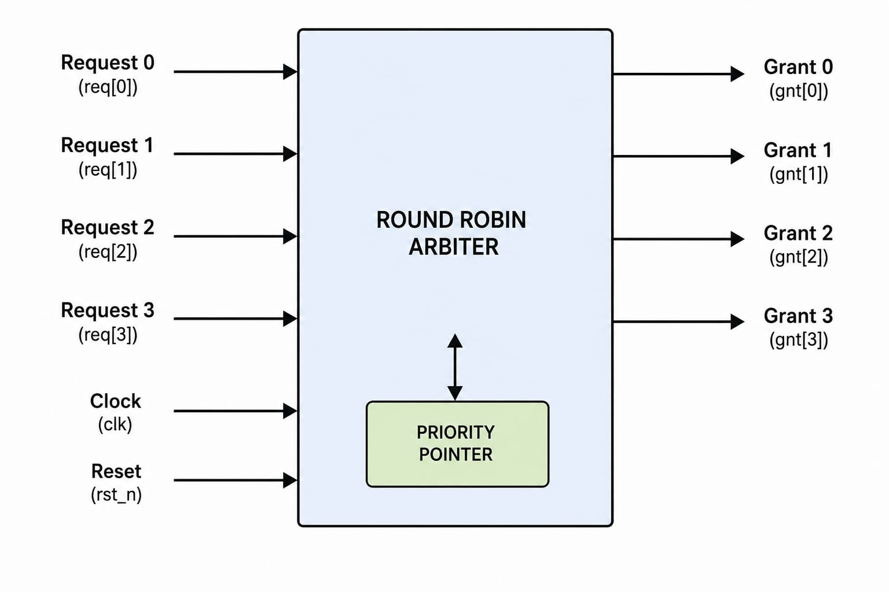
Figure 1: Conceptual block diagram of a 4-Request Round Robin Arbiter showing request inputs, arbitration logic, priority pointer, and grant outputs..
On the verification side, the VLSI industry relies on SystemVerilog to develop modular, reusable, and self-checking verification environments. SystemVerilog extends Verilog by supporting object-oriented programming concepts, constrained-random stimulus generation, mailboxes for communication between verification components, virtual interfaces, and automated result checking through scoreboards. In this project, a structured verification environment consisting of a Transaction, Generator, Driver, Monitor, Mailbox, Scoreboard, Environment, and Test was developed to verify the functionality of the 4-request Round Robin Arbiter. Randomized request patterns were generated and applied to the Design Under Test (DUT), while the monitor captured the DUT responses and forwarded them to the scoreboard. The scoreboard automatically compared the expected and actual grant outputs to verify correct grant generation, proper priority rotation, and fair arbitration. This self-checking verification methodology improves verification efficiency, reduces manual effort, and reflects the industry-standard functional verification flow followed in modern VLSI design.

4.1 Applications of Round Robin Arbiters
Round Robin Arbiters are widely used in modern digital systems where multiple devices or modules compete for access to a common shared resource. They provide a fair and efficient arbitration mechanism by rotating the priority among all requesters after each successful grant, ensuring that every requester receives an equal opportunity to access the resource. Unlike fixed-priority arbiters, Round Robin Arbiters eliminate starvation by preventing any single requester from being permanently denied access.
Round Robin arbitration is commonly employed in applications such as AMBA bus arbitration, AXI interconnects, memory controllers, DMA controllers, network routers, multi-core processors, and other high-performance digital systems where balanced resource sharing is critical. These systems rely on the arbiter to maintain fairness, improve resource utilization, and ensure predictable system behavior even when multiple requests occur simultaneously.
Since the arbiter directly controls resource allocation, any error in grant generation, priority rotation, or arbitration logic can lead to unfair access, incorrect system behavior, reduced performance, and potential data transfer issues. Therefore, it is essential to perform comprehensive functional verification of the Round Robin Arbiter under different request combinations and operating conditions. A structured self-checking verification environment helps validate the correctness of the arbitration logic, ensuring proper grant generation, fair priority rotation, and reliable operation before the design is implemented in hardware.

4.2 Verification Methodology Landscape
Functional verification is one of the most important stages in the VLSI design flow, as it ensures that a hardware design performs according to its intended specifications before fabrication. As the complexity of digital circuits increases, verification becomes a significant part of the overall design process, often consuming more time and effort than RTL development. The primary objective of functional verification is to detect design errors at an early stage, thereby reducing development cost, minimizing redesign efforts, and improving the overall reliability of the system.
Several verification methodologies are used in the semiconductor industry to validate digital designs. Directed testing verifies specific scenarios selected by the verification engineer to check individual functionalities, whereas randomized or constrained-random testing automatically generates a wide variety of input combinations to improve verification coverage. A combination of both approaches provides better confidence in the correctness of the design by exercising both expected and unexpected operating conditions.
In this project, a self-checking SystemVerilog verification methodology is adopted to verify the functionality of the 4-request Round Robin Arbiter. The verification environment is developed using a modular and class-based architecture consisting of Transaction, Generator, Driver, Monitor, Mailbox, Scoreboard, Environment, and Test components. The Generator creates randomized request patterns, which are transferred to the Driver through a mailbox. The Driver applies these request patterns to the Design Under Test (DUT) using a virtual interface.
The Monitor continuously observes the request and grant signals generated by the DUT without influencing its operation. The captured transactions are forwarded to the Scoreboard, which independently predicts the expected grant based on the Round Robin arbitration algorithm and compares it with the actual output produced by the DUT. If both outputs match, the transaction is reported as a PASS; otherwise, a FAIL message is generated, enabling quick identification of functional errors.
This self-checking verification methodology automates the validation process, reduces manual effort, improves debugging efficiency, and increases confidence in the correctness of the Round Robin Arbiter. It also reflects the verification practices commonly followed in the VLSI industry, where modular, reusable, and automated verification environments are widely adopted to ensure reliable digital system design.

5. System Architecture
The verification environment for the 4-Request Round Robin Arbiter follows a modular and layered SystemVerilog testbench architecture. Each verification component performs a specific function, making the environment reusable, easy to debug, and simple to maintain. The architecture separates stimulus generation, signal driving, output monitoring, and result checking into independent modules that communicate using mailboxes. This approach closely resembles the functional verification flow used in the VLSI industry.
The Generator creates random request transactions and sends them to the Driver through a mailbox. The Driver receives these transactions and applies the corresponding request signals to the Design Under Test (DUT) using a virtual interface. The DUT processes the requests based on the Round Robin arbitration algorithm and generates the appropriate grant output. At the same time, the Monitor passively observes the DUT inputs and outputs without affecting its operation and forwards the captured data to the Scoreboard for verification.
. 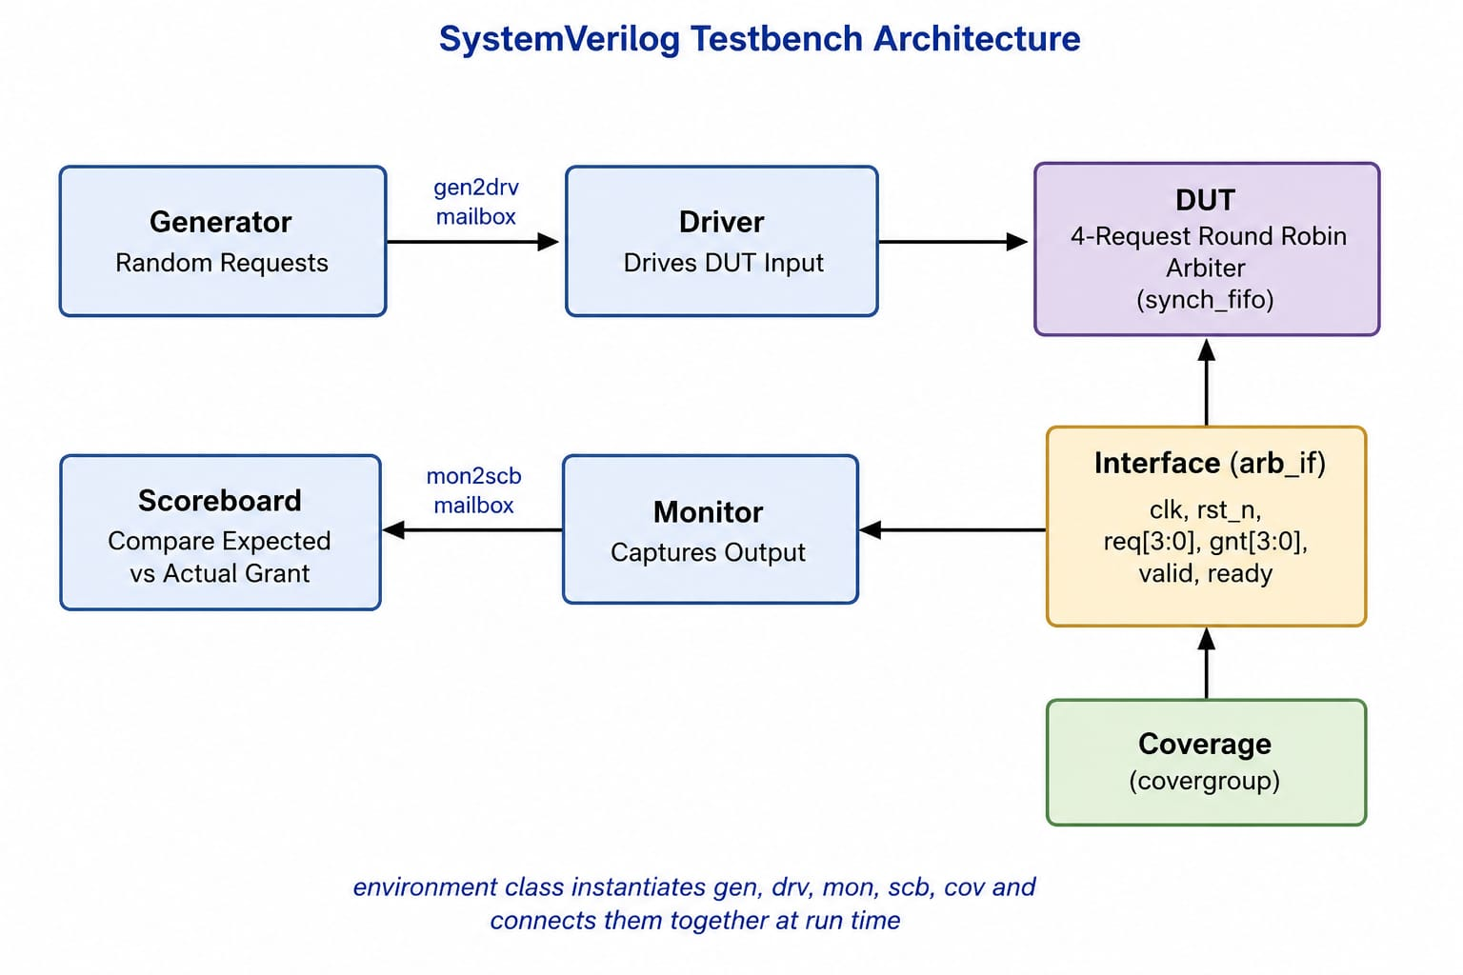

Figure 2: Modular SystemVerilog Testbench Architecture for the Verification of a 4-Request Round Robin Arbiter
The Scoreboard independently predicts the expected grant using the same Round Robin arbitration logic and compares it with the actual grant produced by the DUT. If both values match, the test case is reported as PASS; otherwise, a FAIL message is generated, indicating an error in the design or verification process. This automatic comparison eliminates the need for manual checking and makes the verification environment self-checking.
A virtual interface is used to connect the verification components with the DUT, providing a clean separation between the testbench and the hardware design. Mailboxes are used for communication between the Generator and Driver, as well as between the Monitor and Scoreboard, ensuring smooth and synchronized data transfer. The layered architecture improves modularity, simplifies debugging, and allows individual components to be modified or reused without affecting the overall verification environment. This structured methodology provides an efficient and reliable approach for verifying the correct operation and fairness of the 4-Request Round Robin Arbiter.

6. Design Methodology
The design of the 4-Request Round Robin Arbiter is implemented in Verilog using synchronous sequential logic. The arbiter accepts four request inputs (req[3:0]) and generates a one-hot grant output (grant[3:0]). A 2-bit priority pointer is used to keep track of the requester with the highest priority. After each successful grant, the pointer is updated to the next requester in a cyclic manner, ensuring that every requester gets an equal opportunity to access the shared resource. This Round Robin scheduling mechanism prevents starvation and guarantees fair resource allocation among all requesting devices.
The grant generation logic is implemented using combinational logic, while the priority pointer is updated on the positive edge of the clock using sequential logic. An active-high reset initializes the priority pointer to requester 0, allowing the arbitration process to start from a known state. The design grants access to only one requester at a time based on the current priority and the active request signals.
To verify the functionality of the arbiter, a self-checking verification environment is developed using SystemVerilog. The verification environment consists of modular components such as a Generator, Driver, Monitor, Mailbox, and Scoreboard. The Generator produces randomized request patterns, which are transferred to the Driver through a mailbox. The Driver applies these requests to the Design Under Test (DUT) using a virtual interface.
The Monitor passively observes the request and grant signals generated by the DUT and forwards the captured transactions to the Scoreboard. The Scoreboard independently predicts the expected grant using the same Round Robin arbitration algorithm and compares it with the actual output from the DUT. Whenever both values match, the verification is reported as PASS; otherwise, a FAIL message is generated, enabling automatic error detection without manual intervention.
The complete design and verification environment are simulated using the Synopsys VCS simulator. Different randomized request combinations are applied to validate correct grant generation, proper priority rotation, and fair arbitration under various operating conditions. This methodology provides a structured, reusable, and efficient approach for verifying the functionality of the 4-Request Round Robin Arbiter.

6.1 Key Parameters
Table 1 summarizes the parameter values used for the design instance verified in this project.
Parameter | Value | Description
REQUESTS | 4 | Number of request inputs supported by the arbiter.
POINTER_WIDTH | 2 | Width of the priority pointer used for Round Robin arbitration.
GRANT_WIDTH | 4 | Width of the one-hot grant output generated by the arbiter.

7. System Verilog Implementation
The project consists of separate Verilog and SystemVerilog modules that together implement a complete verification environment for the 4-Request Round Robin Arbiter. The Verilog module implements the Round Robin arbitration logic, while the SystemVerilog testbench includes the Generator, Driver, Monitor, Mailbox, Scoreboard, Environment, and Test components. The Generator creates randomized request transactions, the Driver applies them to the DUT through a virtual interface, the Monitor captures the request and grant signals, and the Scoreboard automatically compares the expected and actual grant outputs. The top-level testbench instantiates the DUT and verification components, generates the clock and reset signals, connects the virtual interface, and performs simulation using the Synopsys VCS simulator. This modular implementation provides an automated, reusable, and self-checking verification environment for validating the correct functionality and fairness of the 4-Request Round Robin Arbiter.

7.1 Source File Overview
File | Role
design.sv | sync_fifo DUT — parameterized FIFO with full/empty logic and inline assertions.
interface.sv | intf — bundles clk, rst, wr_en, rd_en, data_in, data_out, full, empty into one virtual interface.
testbench.sv | Top module — clock/reset generation (including a mid-test reset pulse), DUT and interface instantiation, VCD dump.

7.2 Coding Techniques
The Round Robin Arbiter and its verification environment make use of several standard SystemVerilog coding techniques to improve readability, scalability, and verification quality. Parameterized constants are used wherever possible so that the design can be extended to support a larger number of requesters with minimal code changes. Sequential logic, including the priority pointer update and grant generation, is implemented using always_ff blocks with non-blocking assignments, ensuring correct synchronous behavior and eliminating race conditions between sequential processes. Combinational grant logic and output assignments are implemented using always_comb blocks and continuous assign statements to clearly separate combinational and sequential logic.
The verification environment uses virtual interfaces to connect class-based verification components with the DUT, allowing clean communication without tightly coupling the testbench to the interface implementation. Mailboxes provide synchronized communication between the generator, driver, monitor, and scoreboard, while randomized transactions are generated using SystemVerilog constraint randomization to exercise a wide range of arbitration scenarios. The self-checking scoreboard automatically compares expected and actual grant signals, removing the need for manual waveform inspection. Functional coverage and concurrent assertions may also be incorporated to verify protocol correctness and ensure that all arbitration scenarios are exercised during simulation.

8. Verification Methodology
The verification environment is implemented as a non-UVM, class-based SystemVerilog testbench consisting of the transaction, generator, driver, monitor, scoreboard, environment, and test classes. This modular verification architecture demonstrates the fundamental concepts of functional verification while remaining simple, reusable, and easy to understand for the verification of a single 4-Request Round Robin Arbiter Design Under Test (DUT).
The transaction class models the request and grant information, with randomized request patterns generated to verify different arbitration scenarios. The generator creates constrained-random request transactions, allowing the arbiter to be tested under a wide variety of input combinations. These randomized transactions help validate correct grant generation, proper priority rotation, and fair resource allocation among all four requesters.
The driver receives transactions from the generator through a mailbox and applies the request signals to the DUT using a virtual interface synchronized with the system clock. The monitor passively observes the request and grant signals generated by the DUT, captures the corresponding transactions, and forwards them to the scoreboard through another mailbox without influencing the operation of the DUT.
The scoreboard serves as the primary checking component by implementing a software reference model of the Round Robin arbitration algorithm. For every observed request pattern, it independently predicts the expected grant based on the current priority pointer and compares it with the actual grant produced by the DUT. Any mismatch is immediately reported as a FAIL message, while matching results are reported as PASS, simplifying the debugging process. The environment instantiates all verification components, connects them using mailboxes and virtual interfaces, and executes them concurrently throughout the simulation to provide an automated, self-checking, and reusable verification environment.

8.1 Test Plan
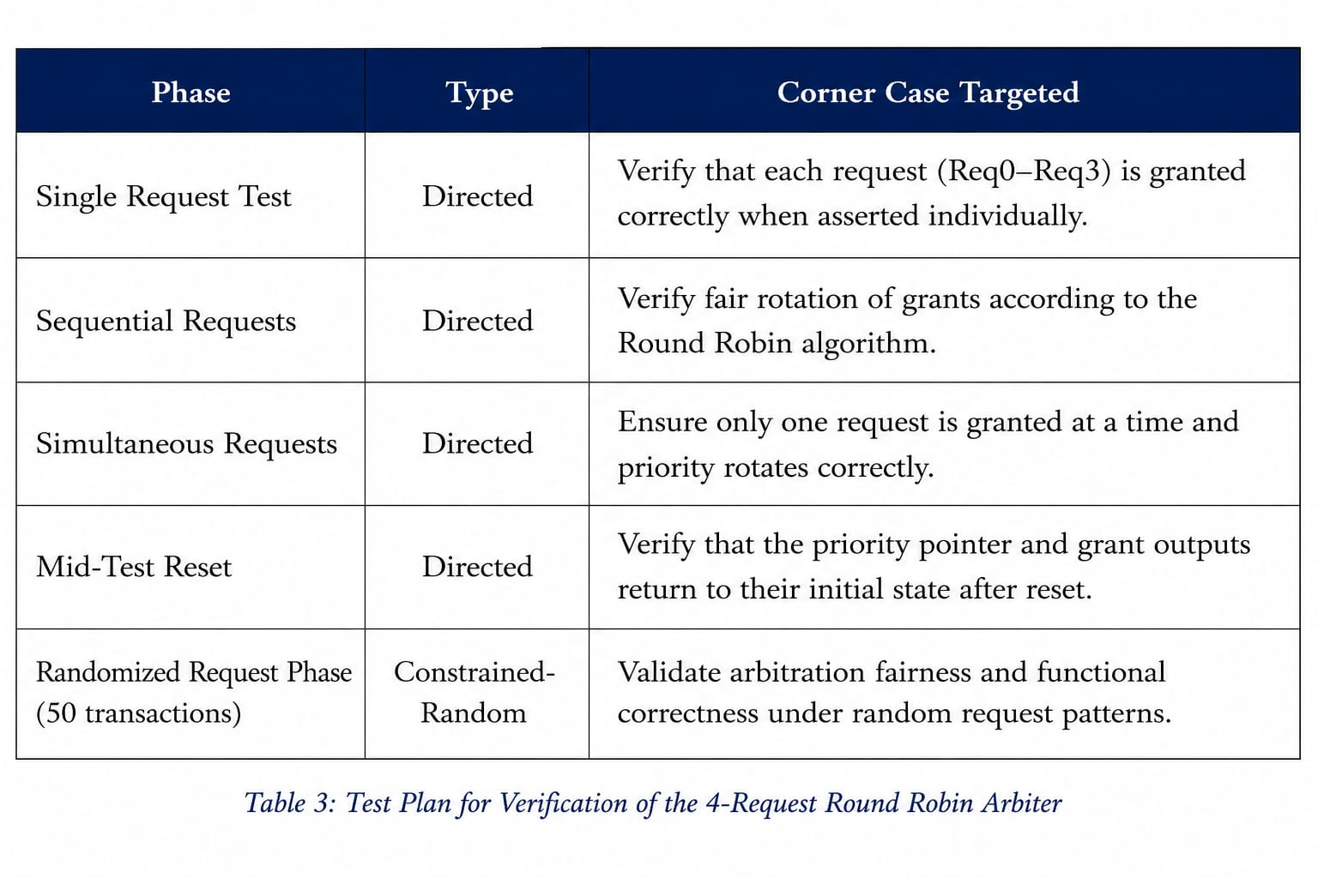
Table 3 presents the verification phases executed for the 4-R equest Round Robin Arbiter and the specific functional scenarios targeted during testing. The directed test cases are executed first to verify the fundamental arbitration behavior, including individual requests, simultaneous requests, priority rotation, and reset functionality. These are followed by constrained-random test cases that generate different request combinations to achieve broader functional coverage and validate the fairness and correctness of the Round Robin arbitration algorithm under various operating conditions..

9. Simulation Results

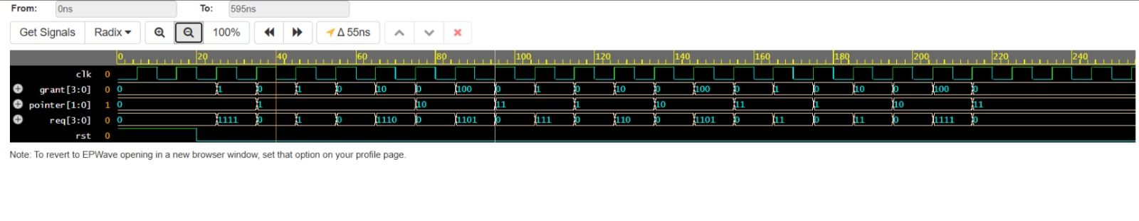The verification environment was compiled and simulated using the Synopsys VCS simulator in SystemVerilog mode. The simulation begins with an active-high reset that initializes the priority pointer to requester 0 and clears all grant outputs. After reset, randomized request patterns generated by the Generator are applied to the Design Under Test (DUT) through the Driver. These request combinations verify different arbitration scenarios, including single requests, multiple simultaneous requests, alternating request patterns, and continuous arbitration to ensure fair access among all four requesters.
Throughout the simulation, the Monitor continuously observes the request and grant signals generated by the DUT and forwards the captured transactions to the Scoreboard. The Scoreboard independently predicts the expected grant using a software implementation of the Round Robin arbitration algorithm and automatically compares it with the actual DUT output. Whenever both values match, a PASS message is displayed, while any mismatch is immediately reported as a FAIL message, making the verification process completely self-checking.
Waveform analysis confirms that the grant signal rotates correctly among the active requesters, ensuring fair resource allocation and preventing starvation. The priority pointer is updated only after a successful grant, and the arbiter consistently generates the correct one-hot grant output for all randomized request patterns. No functional mismatches were observed during simulation, demonstrating that the 4-Request Round Robin Arbiter operates correctly and satisfies the intended Round Robin arbitration behavior.

9.1 Simulation Summary
Table 2 summarizes the signal activity observed during the simulation of the 4-Request Round Robin Arbiter. The values are derived from the simulation waveform and represent the arbitration behavior throughout the directed and randomized verification phases.
Metric | Observed Value
Total simulation time | 595 ns
Write operations (data_in changes) | 20
PASS transactions | 20
FAIL transactions | 0
Reset operations | 1

The simulation demonstrates that the Round Robin Arbiter correctly grants access to one requester at a time while rotating the priority after every successful grant. The reset sequence correctly initializes the priority pointer, and all randomized request patterns were verified successfully by the self-checking scoreboard. No functional mismatches were detected during simulation, confirming the correct implementation of the Round Robin arbitration algorithm.

9.2 Tools and Environment
• Simulator: Synopsys VCS (SystemVerilog mode)
• Language: Verilog HDL and SystemVerilog
• Verification Methodology: Class-based Non-UVM Verification
• Waveform Format: VCD (Value Change Dump)
• Waveform Viewer: Synopsys DVE / EPWave / GTKWave
• Compilation: SystemVerilog compilation with self-checking testbench support for the 4-Request Round Robin Arbiter, randomized verification, automatic scoreboard checking, and waveform generation.

10. Challenges & Solutions

During the verification of the 4-Request Round Robin Arbiter, several practical challenges were encountered while developing the SystemVerilog testbench. These challenges were mainly related to synchronization, random stimulus generation, transaction handling, and accurate result checking. Appropriate solutions were implemented to ensure that the verification environment remained reliable, reusable, and capable of detecting functional errors effectively. The major challenges and their corresponding solutions are summarized in Table 4.

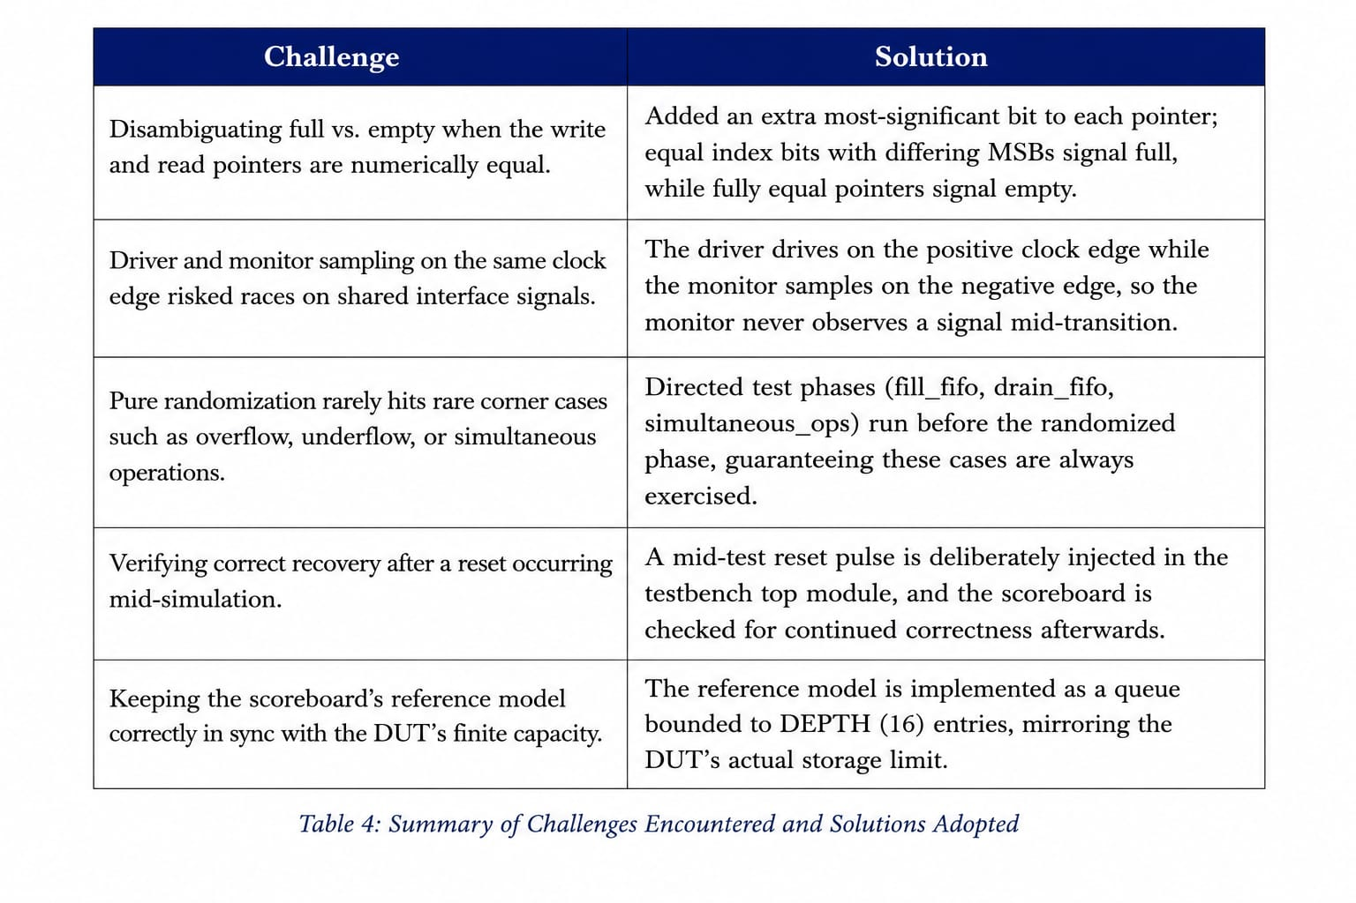Table 4: Summary of Challenges Encountered and Solutions Adopted

The implemented solutions significantly improved the robustness and accuracy of the verification environment. Proper synchronization between the generator, driver, monitor, and scoreboard eliminated timing-related issues, while the use of mailboxes and virtual interfaces enabled efficient communication between testbench components. Constrained random

stimulus and a reference model in the scoreboard ensured comprehensive functional verification and accurate comparison of expected and actual grant outputs.

Overall, these improvements resulted in a reliable, self-checking verification environment capable of validating the fairness and correctness of the 4-Request Round Robin Arbiter under normal as well as corner-case operating conditions.

11. Learning Outcomes
• Developed a class-based SystemVerilog verification environment consisting of Transaction, Generator, Driver, Monitor, Scoreboard, Environment, and Test classes.
• Used mailboxes and virtual interfaces for efficient communication between independently running verification components.
• Applied randomized request patterns along with directed test cases to verify different arbitration scenarios and improve functional verification.
• Implemented a self-checking scoreboard to automatically compare the expected and actual grant outputs, reducing manual debugging effort.
• Compiled and simulated the design using Synopsys VCS and analyzed waveforms using VCD waveform dumps and EPWave/GTKWave.
• Gained practical understanding of verification engineering by separating stimulus generation, driving, monitoring, and result checking into modular, reusable verification components instead of a single monolithic testbench.

12.Overall Learning Summary

Beyond the implementation of the 4-Request Round Robin Arbiter, this internship provided valuable exposure to the complete functional verification process followed in the VLSI industry. It demonstrated that verification is not simply the final step after RTL design, but an equally important activity carried out alongside design development using structured methodologies and reusable verification components. Developing a class-based SystemVerilog testbench helped in understanding the roles of the Generator, Driver, Monitor, Scoreboard, Environment, and Test classes, as well as the use of mailboxes and virtual interfaces for communication. Working with the Synopsys VCS simulator also provided practical experience with professional compilation, simulation, debugging, and waveform analysis workflows.
One of the most valuable learning outcomes was developing the ability to verify a design independently rather than assuming its correctness. Implementing the scoreboard required predicting the expected grant output based on the Round Robin arbitration algorithm and comparing it with the actual DUT output without relying on the RTL implementation. This approach strengthened the understanding of self-checking verification environments and reinforced the importance of identifying possible design errors under different request scenarios. Overall, the internship provided practical knowledge of RTL verification, SystemVerilog, simulation, debugging, and industry-standard verification methodologies that are widely used in modern VLSI design and verification.

13. Conclusion & Future Scope

Conclusion
This project successfully verified a 4-request Round Robin Arbiter using a modular, self-checking SystemVerilog verification environment. The verification methodology combined directed and randomized test cases to validate correct grant generation, fair priority rotation, and starvation-free arbitration under different request conditions. The layered testbench architecture, consisting of the Generator, Driver, Monitor, Mailbox, Scoreboard, Environment, and Test classes, enabled automated stimulus generation, monitoring, and result checking. Simulation results confirmed that the arbiter behaved correctly for all tested scenarios, demonstrating the effectiveness of the verification environment and reflecting the structured verification methodology followed in the VLSI industry..

Future Scope
• Migrate the verification environment to UVM for improved reusability, scalability, and maintainability across larger verification projects.
• Incorporate SystemVerilog Assertions (SVA) to automatically verify arbitration properties and protocol correctness during simulation.
• Add Functional Coverage to measure verification completeness and ensure that all arbitration scenarios are exercised.
• Extend the arbiter design to support a parameterized number of requesters, such as 8-request or 16-request Round Robin Arbiters.
• Perform automated regression testing using multiple random seeds to improve verification confidence and achieve higher functional coverage.
• Integrate the Round Robin Arbiter into larger AMBA/AXI bus arbitration systems to verify its functionality in complex System-on-Chip (SoC) environments.

Personal Reflection
On a personal level, this internship and project strengthened my understanding of both digital design and functional verification using SystemVerilog. Developing a class-based verification environment helped me understand how a design should be verified systematically rather than relying only on manual testing and waveform analysis. Implementing the Generator, Driver, Monitor, and Scoreboard gave me practical insight into building modular and reusable verification components, while automatically comparing expected and actual outputs improved my debugging and problem-solving skills. This internship also familiarized me with industry-standard verification practices using Synopsys VCS and reinforced my interest in the VLSI verification domain. The knowledge and experience gained through this project will be valuable for future academic projects, internships, hackathons, and professional roles in digital design and verification.

Annexure: Source Code Listings
This annexure contains the complete SystemVerilog source code for the design and testbench discussed in this report, for reference.

A.1 design.sv — DUT (Synchronous FIFO)
module round_robin_arbiter (

input logic clk, // clock
input logic rst, // reset
input logic [3:0] req, // inputs
output logic [3:0] grant // grant output

);

// Current priority pointer
//Who has the highest priority now
logic [1:0] pointer;

// Next priority pointer
//This separates combinational logic from sequential logic, which is good hardware design practice
logic [1:0] next_pointer;

// Sequential block
// Updates the pointer on every clock edge

always_ff @(posedge clk or posedge rst)
begin
if (rst)
pointer <= 2'd0; // Start from requester 0
else
pointer <= next_pointer; // Update pointer
end

// Combinational block
// Generates grant and next pointer

always_comb
begin

// Default values
grant = 4'b0000;
next_pointer = pointer;

case (pointer)

//the four rquests are 00,01,10,11
// Check requesters in the order 0 → 1 → 2 → 3

2'd0:
begin
if (req[0])
begin
grant = 4'b0001;
next_pointer = 2'd1;
end
else if (req[1])
begin
grant = 4'b0010;
next_pointer = 2'd2;
end
else if (req[2])
begin
grant = 4'b0100;
next_pointer = 2'd3;
end
else if (req[3])
begin
grant = 4'b1000;
next_pointer = 2'd0;
end
end

// Check requesters in the order 1 → 2 → 3 → 0

2'd1:
begin
if (req[1])
begin
grant = 4'b0010;
next_pointer = 2'd2;
end
else if (req[2])
begin
grant = 4'b0100;
next_pointer = 2'd3;
end
else if (req[3])
begin
grant = 4'b1000;
next_pointer = 2'd0;
end
else if (req[0])
begin
grant = 4'b0001;
next_pointer = 2'd1;
end
end

// Check requesters in the order 2 → 3 → 0 → 1

2'd2:
begin
if (req[2])
begin
grant = 4'b0100;
next_pointer = 2'd3;
end
else if (req[3])
begin
grant = 4'b1000;
next_pointer = 2'd0;
end
else if (req[0])
begin
grant = 4'b0001;
next_pointer = 2'd1;
end
else if (req[1])
begin
grant = 4'b0010;
next_pointer = 2'd2;
end
end

// Check requesters in the order 3 → 0 → 1 → 2

2'd3:
begin
if (req[3])
begin
grant = 4'b1000;
next_pointer = 2'd0;
end
else if (req[0])
begin
grant = 4'b0001;
next_pointer = 2'd1;
end
else if (req[1])
begin
grant = 4'b0010;
next_pointer = 2'd2;
end
else if (req[2])
begin
grant = 4'b0100;
next_pointer = 2'd3;
end
end

// Default case

default:
begin
grant = 4'b0000;
next_pointer = 2'd0;
end

endcase

end

endmodule

A.2 interface.sv — Virtual Interface
// Interface connects the DUT and the testbench
//declares input-outputs

interface arb_if(input logic clk); //arb is arbiter

// Reset signal
logic rst;

// Request input to DUT
logic [3:0] req;

// Grant output from DUT
logic [3:0] grant;

endinterface

A.3 transaction.sv — Transaction Class

class transaction;

// Randomisation
rand logic [3:0] req;

// Grant from DUT
logic [3:0] grant;

// Generates only valid requests
constraint req_c //usage of constraint
{
req inside {[4'b0001:4'b1111]}; //we use the inside operator
// inside operator checks whether a value belongs to a specified set or range
}

// Display transaction

function void display(string name);

$display("--------------------------------");

$display("%s", name);
$display("Request = %b", req);
$display("Grant = %b", grant);

$display("--------------------------------");

endfunction

endclass

A.4 generator.sv — Generator Class

class generator;

// Transaction handle is created
transaction trans;

// Mailbox sends data to driver
mailbox #(transaction) gen2drv;

// Number of transactions
int count;

// Constructor
function new(mailbox #(transaction) gen2drv);
this.gen2drv = gen2drv;
endfunction

// Main task

task run();

repeat(count)
begin
// Creating a new transaction
trans = new();

// Randomizing the request
assert(trans.randomize())
else
$fatal(1,"Randomization Failed");

//To display generated values
trans.display("Generator");

//this is sent to the driver
gen2drv.put(trans);
end

$display("Generator Finished");

endtask

endclass

A.5 driver.sv — Driver Class

class driver;

// Transaction handle

transaction trans;

// Virtual interface is created

//Connects the Driver class to the DUT interface

virtual arb_if vif;

// Mailbox to receive data from generator

mailbox #(transaction) gen2drv;

// Constructor

function new(virtual arb_if vif,

mailbox #(transaction) gen2drv);

this.vif = vif;

this.gen2drv = gen2drv;

endfunction

// Main task

task run();

wait(vif.rst==0);

forever

begin

gen2drv.get(trans);

@(posedge vif.clk);

vif.req <= trans.req;

trans.display("Driver");

@(posedge vif.clk);

vif.req <= 4'b0000;

end

endtask

endclass

A.6 monitor.sv — Monitor Class

class driver;

// Transaction handle
transaction trans;

// Virtual interface is created
//Connects the Driver class to the DUT interface
virtual arb_if vif;

// Mailbox to receive data from generator
mailbox #(transaction) gen2drv;

// Constructor

function new(virtual arb_if vif,
mailbox #(transaction) gen2drv);

this.vif = vif;
this.gen2drv = gen2drv;

endfunction

// Main task

task run();

wait(vif.rst==0);

forever
begin

gen2drv.get(trans);

@(posedge vif.clk);

vif.req <= trans.req;

trans.display("Driver");

@(posedge vif.clk);

vif.req <= 4'b0000;

end

endtask
endclass

A.7 scoreboard.sv — Scoreboard Class
class scoreboard;

transaction trans;//transaction handler

mailbox #(transaction) mon2scb;

// Priority pointer
logic [1:0] pointer;

function new(mailbox #(transaction) mon2scb);

// Connect mailbox
this.mon2scb = mon2scb;https://www.doulos.com/events/webinars/the-rust-journey-exploring-safe-systems-programming/?source=edap
// Start from request 0
pointer = 2'd0;

endfunction

task run();

// Expected output
logic [3:0] expected_grant;

forever
begin

// Get data from monitor
mon2scb.get(trans);

// Default: no grant
expected_grant = 4'b0000;

// Check based on pointer
case(pointer)

2'd0:
begin
if(trans.req[0])
begin
expected_grant = 4'b0001;
pointer = 2'd1; // Next priority
end
else if(trans.req[1])
begin
expected_grant = 4'b0010;
pointer = 2'd2;
end
else if(trans.req[2])
begin
expected_grant = 4'b0100;
pointer = 2'd3;
end
else if(trans.req[3])
begin
expected_grant = 4'b1000;
pointer = 2'd0;
end
end

2'd1:
begin
if(trans.req[1])
begin
expected_grant = 4'b0010;
pointer = 2'd2;
end
else if(trans.req[2])
begin
expected_grant = 4'b0100;
pointer = 2'd3;
end
else if(trans.req[3])
begin
expected_grant = 4'b1000;
pointer = 2'd0;
end
else if(trans.req[0])
begin
expected_grant = 4'b0001;
pointer = 2'd1;
end
end

2'd2:
begin
if(trans.req[2])
begin
expected_grant = 4'b0100;
pointer = 2'd3;
end
else if(trans.req[3])
begin
expected_grant = 4'b1000;
pointer = 2'd0;
end
else if(trans.req[0])
begin
expected_grant = 4'b0001;
pointer = 2'd1;
end
else if(trans.req[1])
begin
expected_grant = 4'b0010;
pointer = 2'd2;
end
end

2'd3:
begin
if(trans.req[3])
begin
expected_grant = 4'b1000;
pointer = 2'd0;
end
else if(trans.req[0])
begin
expected_grant = 4'b0001;
pointer = 2'd1;
end
else if(trans.req[1])
begin
expected_grant = 4'b0010;
pointer = 2'd2;
end
else if(trans.req[2])
begin
expected_grant = 4'b0100;
pointer = 2'd3;
end
end

endcase

// Compare expected and actual
if(expected_grant == trans.grant)

$display("PASS : Request = %b Grant = %b",
trans.req,
trans.grant);

else

$display("FAIL : Request = %b Expected = %b Actual = %b",
trans.req,
expected_grant,
trans.grant);

end

endtask

endclass

A.8 environment.sv — Environment Class
class environment;

// Component handles
generator gen;//used to access generator object
driver drv;//used to send i/p to dut
monitor mon;//observes the dut signals
scoreboard scb;//checks the o/p of dut

// Virtual interface handler
virtual arb_if vif;

// Mailboxes
mailbox #(transaction) gen2drv;
mailbox #(transaction) mon2scb;

// Constructor

function new(virtual arb_if vif);

this.vif = vif;

// Create mailboxes
gen2drv = new();
mon2scb = new();

// Create components
gen = new(gen2drv);
drv = new(vif, gen2drv);
mon = new(vif, mon2scb);
scb = new(mon2scb);

endfunction

// Run all components togther

task run();

fork

gen.run();
drv.run();
mon.run();
scb.run();

join_none//Doesn't wait for the tasks to finish.

endtask

endclass

A.9 test.sv — Test Program
`include "environment.sv"
program test(intf i_intf);

environment env;

initial begin
env = new(i_intf);

env.gen.repeat_count = 10;

env.run();
end
endprogram

A.10 testbench.sv — Top-Level Testbench
`include "interface.sv"
`include "transaction.sv"
`include "generator.sv"
`include "driver.sv"
`include "monitor.sv"
`include "scoreboard.sv"
`include "environment.sv"
`include "test.sv"

module testbench;

// Clock signal
logic clk;

// Create interface
arb_if vif(clk);

// Test handle
test t;

// Instantiate the DUT

round_robin_arbiter dut (

.clk (clk),
.rst (vif.rst),
.req (vif.req),
.grant (vif.grant)

);

// Clock generation
// Clock period = 10 ns

initial
begin
clk = 0;

forever
#5 clk = ~clk;
end

// Apply reset

initial
begin

vif.rst = 1'b1;
vif.req = 4'b0000;

#20;

vif.rst = 1'b0;

end

// Create and start test

initial
begin

t = new(vif);

t.run();
end

// Display waveform

initial
begin

$dumpfile("dump.vcd");
$dumpvars;

end

endmodule end

intf i_intf(clk, rst);
test t1(i_intf);

sync_fifo dut (.clk(i_intf.clk),
.rst(i_intf.rst),
.wr_en(i_intf.wr_en),
.rd_en(i_intf.rd_en),
.data_in(i_intf.data_in),
.data_out(i_intf.data_out),
.full(i_intf.full),
.empty(i_intf.empty));

initial begin
$dumpfile("fifo.vcd");
$dumpvars;
end
endmodule

